**Use Agile Process in Azure DevOps**

In this assignment, we use ASP.NET Core MVC as our main focus and use Azure DevOps to build Agile software development approaches. We create a project called "MVC Agile Process" and organize it using an Agile Work Item Process. The project's development requirements are arranged through the creation of Epics, Features, User Stories, and Tasks. We also set up two iterations within Sprints to add search and validation features and gradually build MVC functionalities

**Figure 1**

The main epic details with two child features

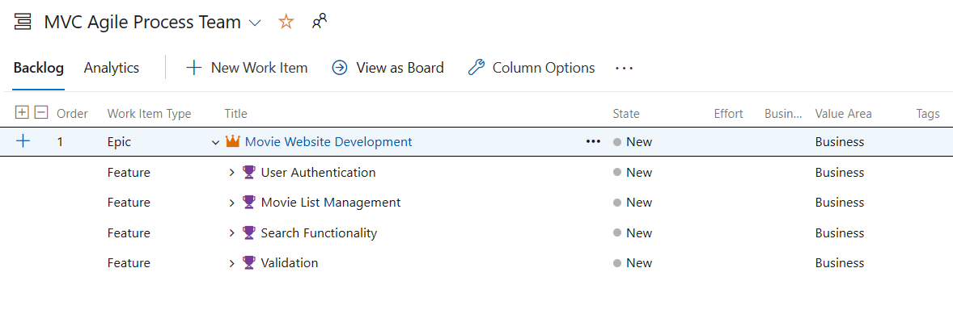

**Figure 2**

Each Feature with details that has child User Story

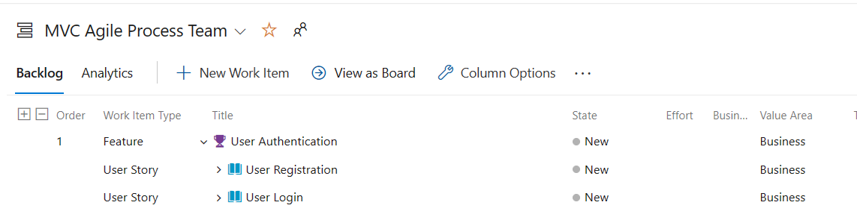

**Figure 3**

Each User Story with details that has child Tasks

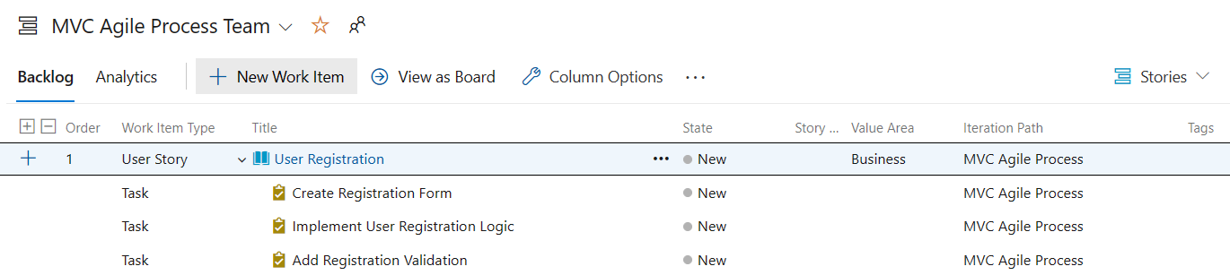

**Figure 4**

Iteration 1 with tasks, start and end date [3 marks]

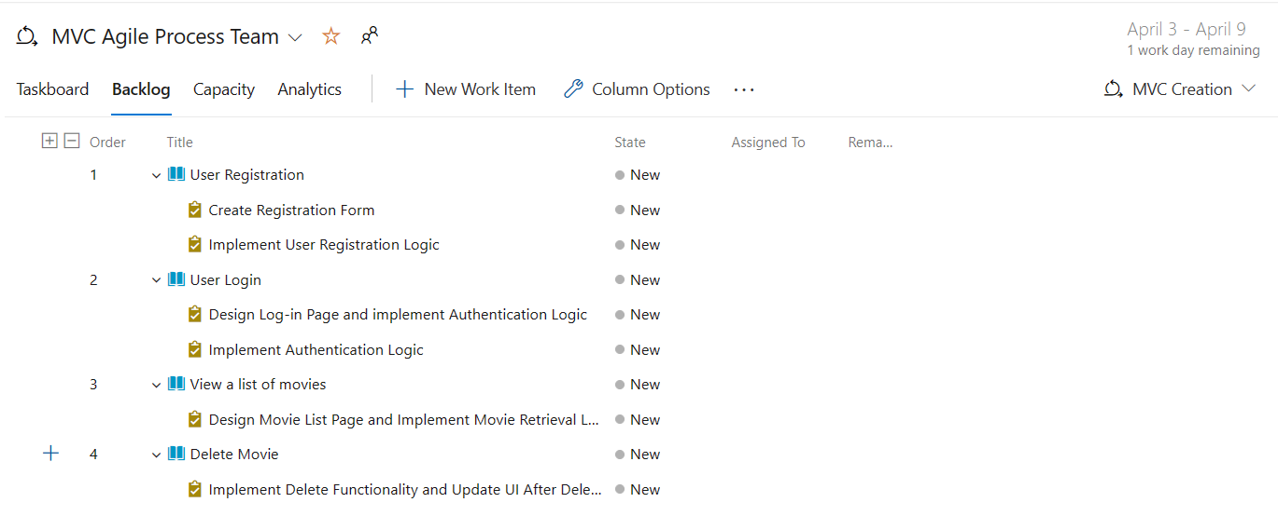

**Figure 5**

Iteration 2 with tasks, start and end date

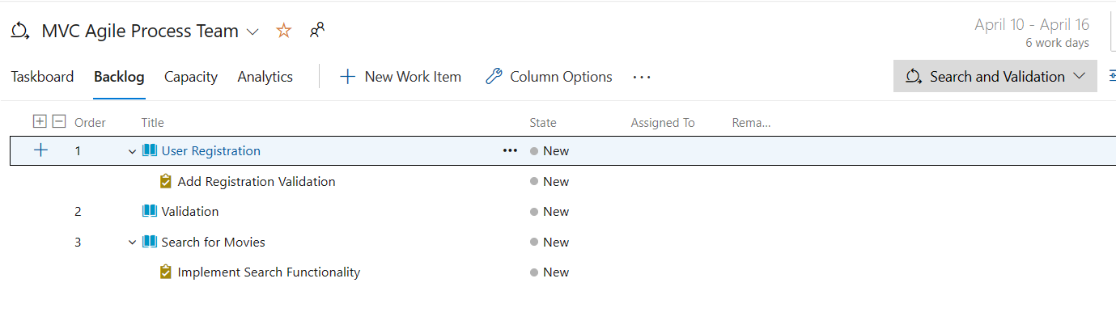

**Figure 6**

Task board showing current sprint details

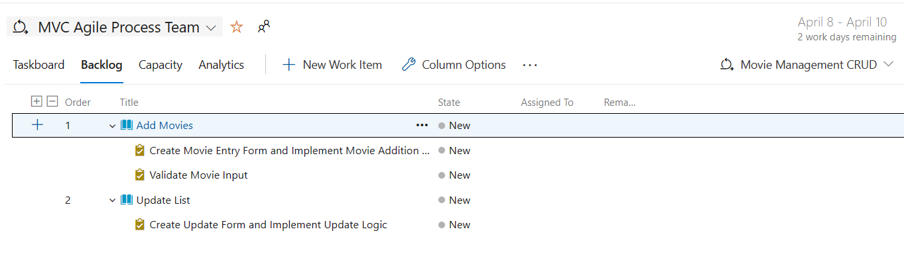

**Figure 7**

Backlog showing User Stories and Features [2 marks]

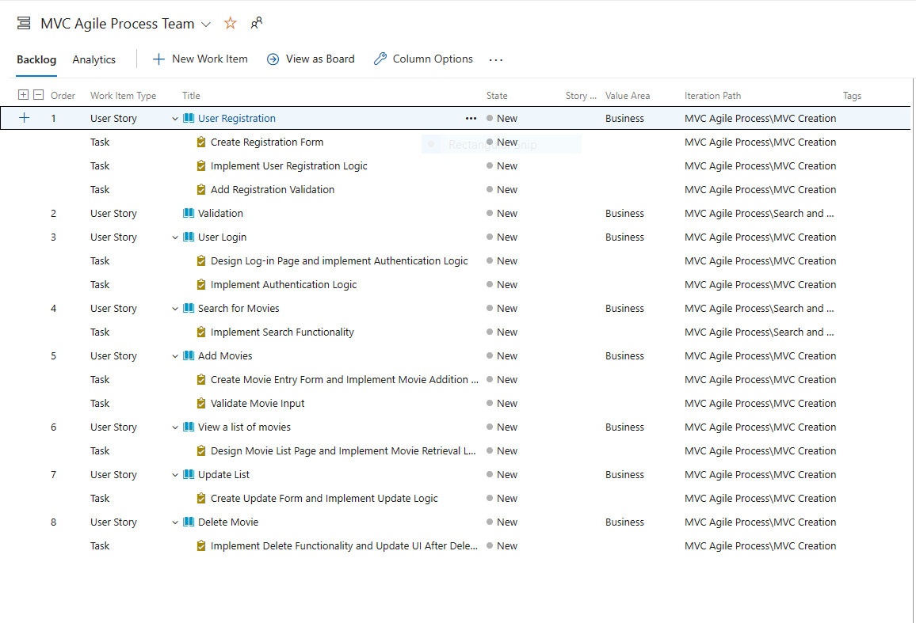

The GitHub URL to the project is [scriptsorcerer04/MVC-Agile-Process (github.com)](https://github.com/scriptsorcerer04/MVC-Agile-Process)

This assignment demonstrates the real-world implementation of software development approaches by fusing Agile and Azure DevOps. The integration of Azure DevOps enables smooth project management and collaboration, while Agile approaches promote flexibility and response to evolving needs. The importance of Agile methodologies and organized project management in contemporary software development workflows is highlighted by this assignment.